SQL Assignment – 7
D2_83822_Rohit
Summarizing Data with Aggregate Functions.

1) ) Write a query that counts all orders for October 3.

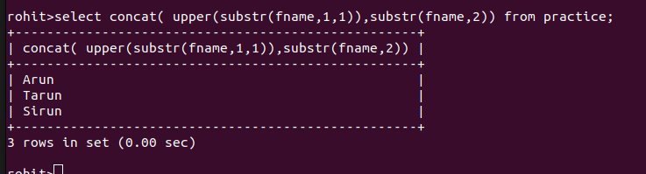

2) Write a query that counts the number of different non-NULL city values in the Customers
table.
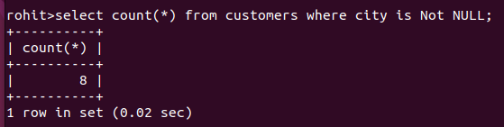

3) Write a query that selects each customer’s smallest order.

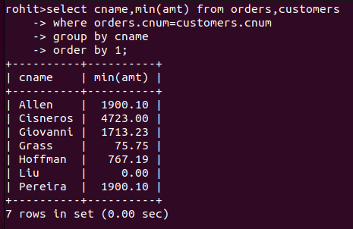

4) Write a query that selects the first customer, in alphabetical order, whose name begins with G.

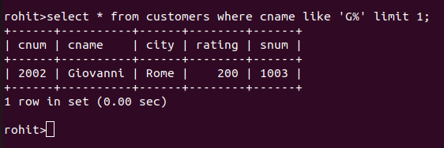

5) Write a query that selects the highest rating in each city.
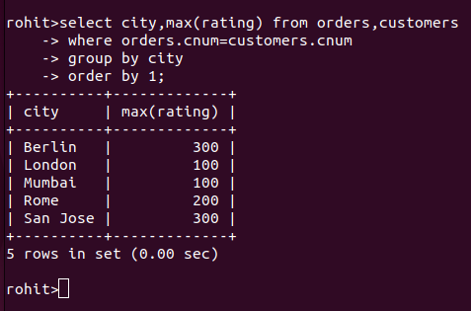

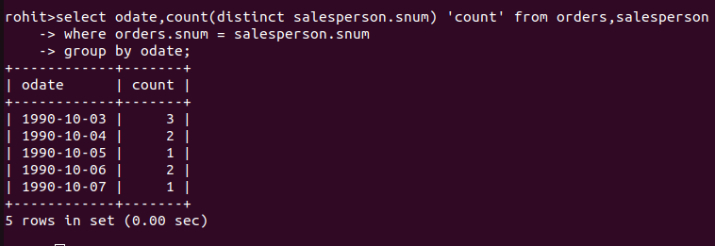
6) Write a query that counts the number of salespeople registering orders for each day. (If a saesperson has more than one order on a givenday, he or she should be counted only once.).

